FOR IMMEDIATE RELEASE Contact: 415-637-7786
info@craigjessup.com
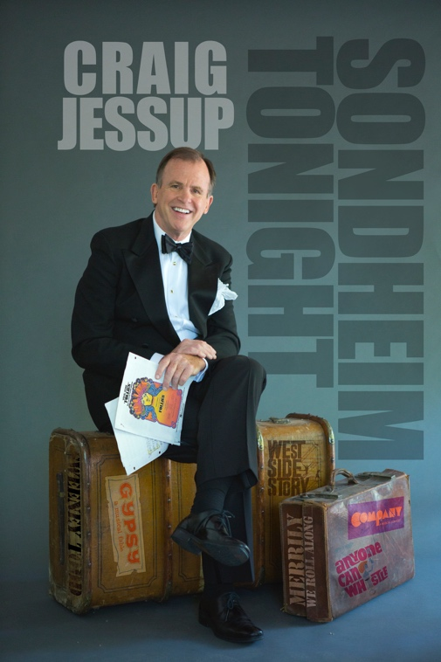
Craig Jessup returns to the
142 Throckmorton Theatre with Sondheim Tonight
with Ken Muir,
musical director

One Night Only!
Saturday, March 23, 2019
8 p.m.

142 Throckmorton Theatre
Mill Valley

Reservations: www.142throckmortontheatre.org
or 415-383-9600

“I love the theater as much as music, and the whole idea of getting across to an audience and making them laugh, making them cry – just making them feel – is paramount to me.”
– Stephen Sondheim

One of the Bay Area’s most beloved entertainers celebrates the work of one of our greatest composers. Craig Jessup’s Sondheim Tonight brings together more than a dozen Sondheim gems from some of his earliest shows as a composer/lyricist (Saturday Night, Anyone Can Whistle) to some of his most celebrated (Company, Follies, Merrily We Roll Along). And the show marks Jessup’s return to the 142 Throckmorton Theatre.

With musical director/accompanist Ken Muir and Paul Blackburn on bass and Tommy Kesecker on drums, Jessup pays tribute to a true master. “Sondheim has meant so much to me personally,” Jessup says. “I can remember being a poor college student in New York second-acting shows like Company and Follies and just being dazzled by his gift for lyrics married to melodies that not only create beautiful, dynamic songs but also reveal the deepest core of his characters.”

A veteran of cabaret and musical theater stages around the world, Jessup was recently described by the San Francisco Chronicle as a performer who can be
“playful or twangy, or edgy and electric. His singing also has a narrative quality

that betrays his musical theater background. Each lyric springs from a deep and distinct emotion; each bit of phrasing is carefully sculpted to communicate an idea with clarity and dynamism.” In other words, Craig Jessup is the ideal interpreter of a Sondheim song.

Stephen Sondheim was a protégé of Oscar Hammerstein as a very young man and first experienced music in the theater when the butler in the musical Very Warm for May dusted the piano on stage and tinkled the keys. Over the next 60- plus years, Stephen Sondheim would prove to be a dominant creative force on Broadway, with a musical education garnered at the hands of composer Milton Babbitt. From a modest debut with a single song in the 1956 stage play, Girls of Summer, Mr. Sondheim was quickly propelled to celebrity by writing the lyrics for two of Broadway’s most beloved musicals, West Side Story (1957) and Gypsy (1959). Since then, he has provided both the words and music for some 16 other Broadway shows, from the 1962 farce, A Funny Thing Happened on the Way to the Forum, to, most recently, Road Show. Among his most beloved shows are Company (1971), Follies (1971), Sweeney Todd (1979) and Into the Woods (1987). Mr. Sondheim, at age 88, is writing a new musical inspired by Luis Buñuel’s films The Discreet Charm of the Bourgeoisie and The Exterminating Angel. Mr. Sondheim has been nominated for 26 Tony Awards as lyricist and composer and has won 14 times, including a lifetime achievement Tony Award in 2008. He won the 1985 Pulitzer Prize for Drama for Sunday in the Park with George, which was revived on Broadway most recently in 2017. He received an Academy Award for Best Original Song for “Sooner or Later” from Dick Tracy.

Craig Jessup has played theaters, cabarets and concert halls throughout the U.S., Canada and Europe for more than two decades. Jessup teamed with Ruth Hastings and Barry Lloyd in 1977 to form Ruth Hastings & Co., and the trio played nearly every cabaret in San Francisco including Le Domino, Chez Jacques, Gordon’s, Fanny’s, Trinity Place and the Plush Room, culminating in a sold-out concert at the Geary Theatre which was recorded live. A highly successful run of Jacques Brel is Alive and Well and Living in Paris at Chez Jacques resulted in an invitation to perform the acclaimed musical revue in Brussels, Belgium at the Belgian National Opera Company just after Brel’s death. On his own, Jessup, who was described by the San Francisco Examiner as “smooth, clever and quite wonderful,” has appeared in musicals and revues with Artstreet Theatre, Rohnert Park’s Pacific Alliance Theatre Company, Broadway by the Bay (San Mateo), American Conservatory Theatre, 42nd Street Moon, the Aurora Theatre Company and Marin’s Alter Theater Ensemble.

Ken Muir is a San Francisco based pianist/arranger/composer/lyricist who has worked in the Bay Area for more than 25 years, also performing regularly in New York and occasionally in Europe. He played and arranged for each of vocalist Paula West's three CDs and has accompanied many of other fine singers, both on recordings and at the Plush Room. Ken is currently preparing for a recording and revue of his own music and lyrics.

FOR MORE INFORMATION

Watch videos and hear music samples at www.craigjessup.com. Download photos at https://www.craigjessup.com/press

FOR CALENDAR EDITORS

Craig Jessup: Sondheim Tonight!
with Ken Muir, musical director

One night only!

Saturday, March 23, 2019
8 p.m.
142 Throckmorton Theatre
Mill Valley

Reservations: www.142throckmortontheatre.org or 415-383-9600

